Mesh API offer for Krish's students
Mesh API is a unified LLM gateway that gives you access to 300+ models from OpenAI, Anthropic, Google, Meta, Mistral, DeepSeek, Qwen, and others through a single API key. It's OpenAI-compatible, so you change one line and keep everything else.

Visit https://meshapi.ai/ and click Get API Key

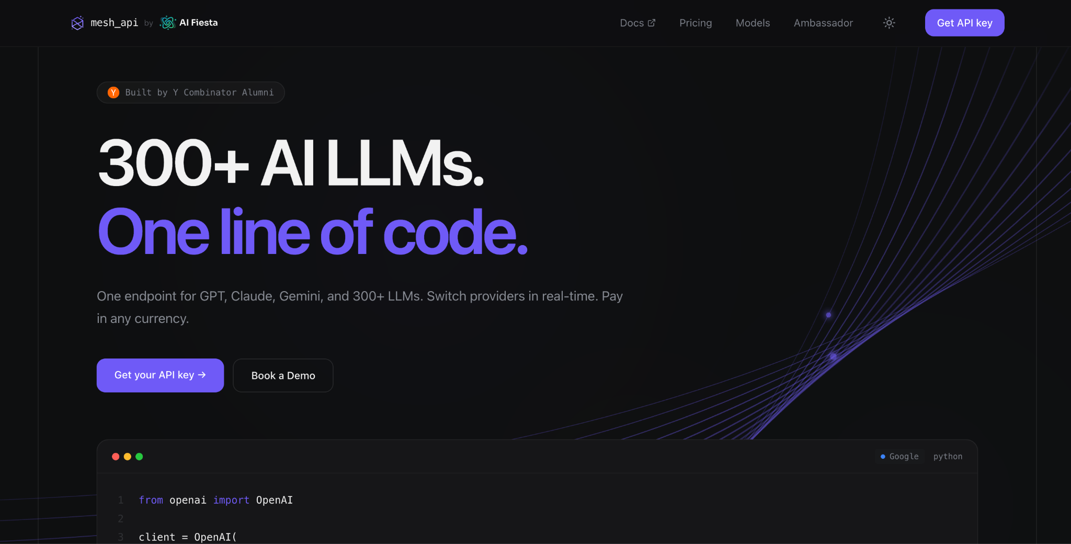

You'll be redirected to app.meshapi.ai
Sign up with your email or log in if you already have an account.
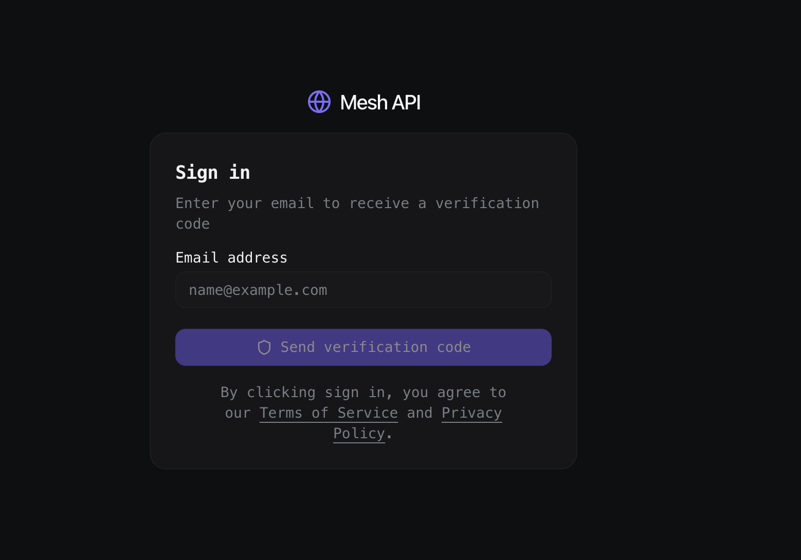

Check your inbox for a verification code and enter it to continue.
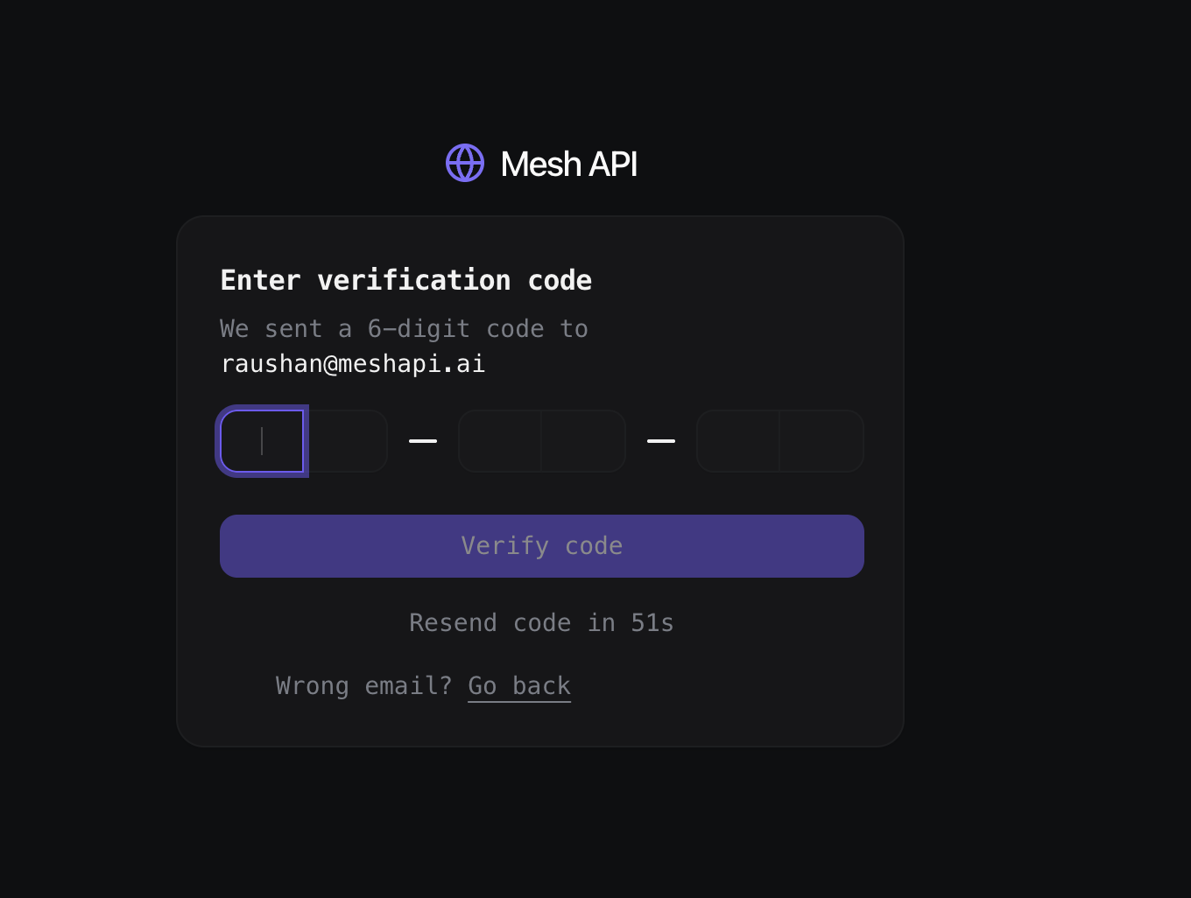

Once you're signed in, you'll land on the Mesh API dashboard.
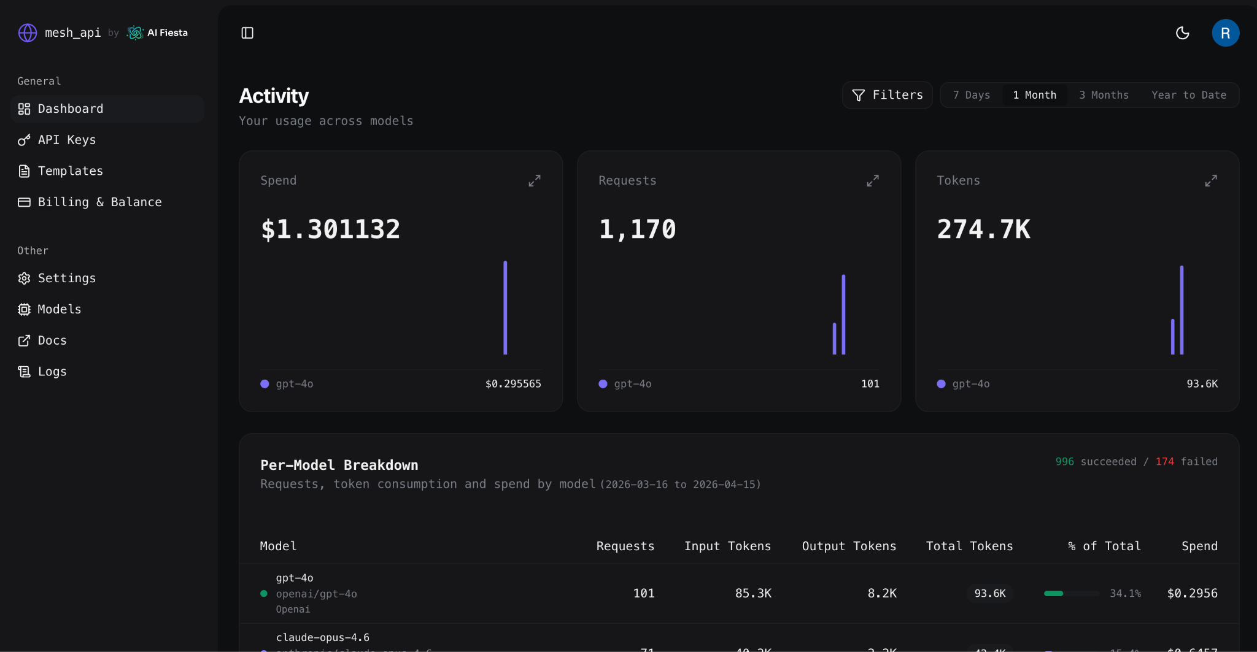

From the left sidebar, open Billing & Balance to top up your account.
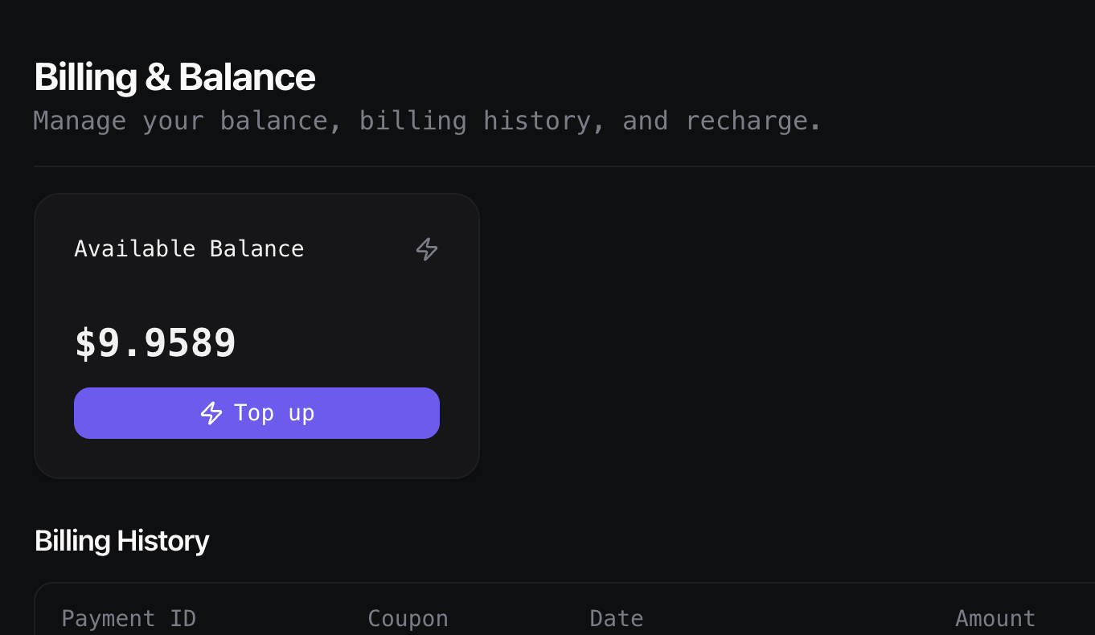

Enter ₹250 as the top-up amount
- Leave the coupon field empty at this stage.
- Click Pay ₹295 to proceed - don't worry, we'll apply the coupon on the next screen.
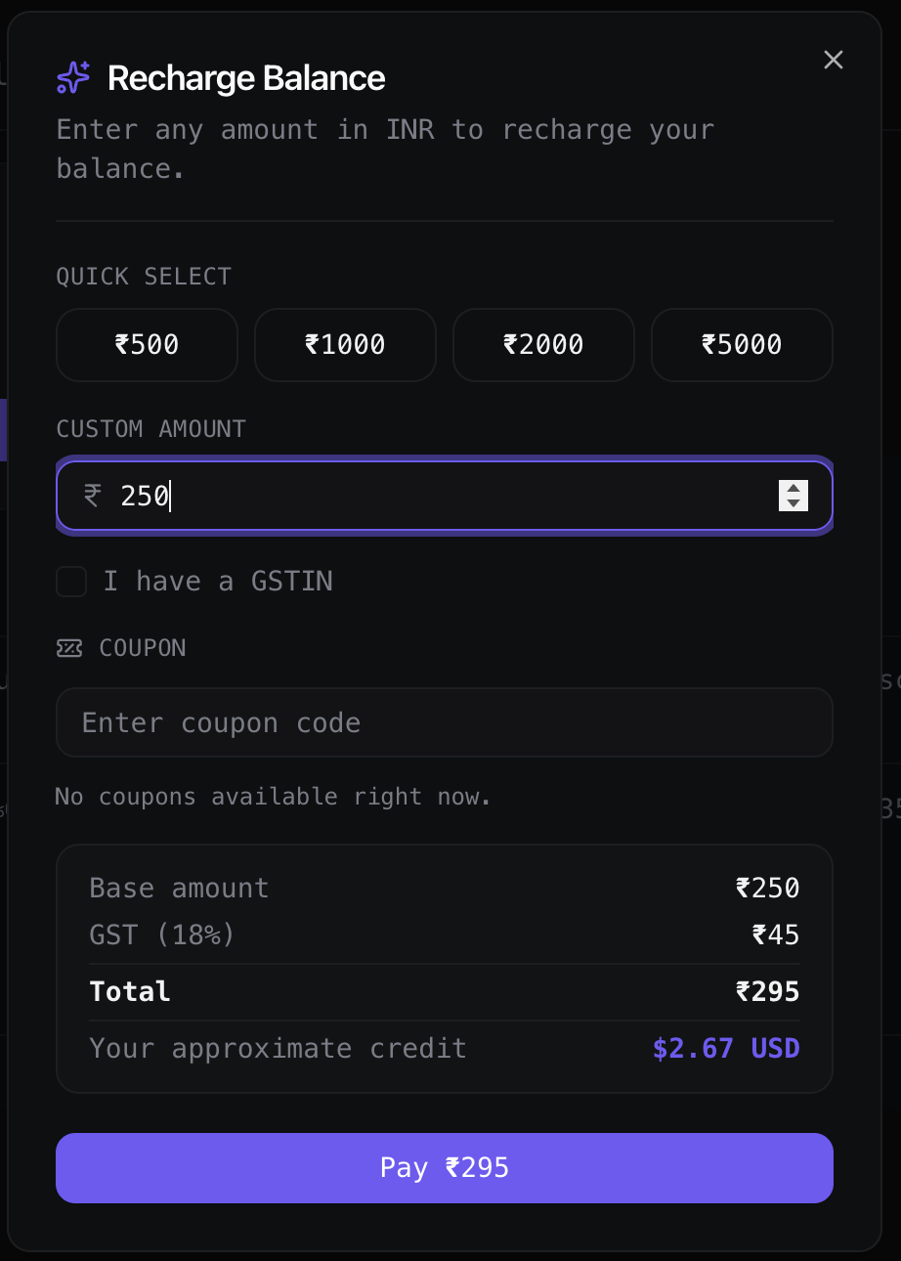

On the payment page, click Offers and Coupons.
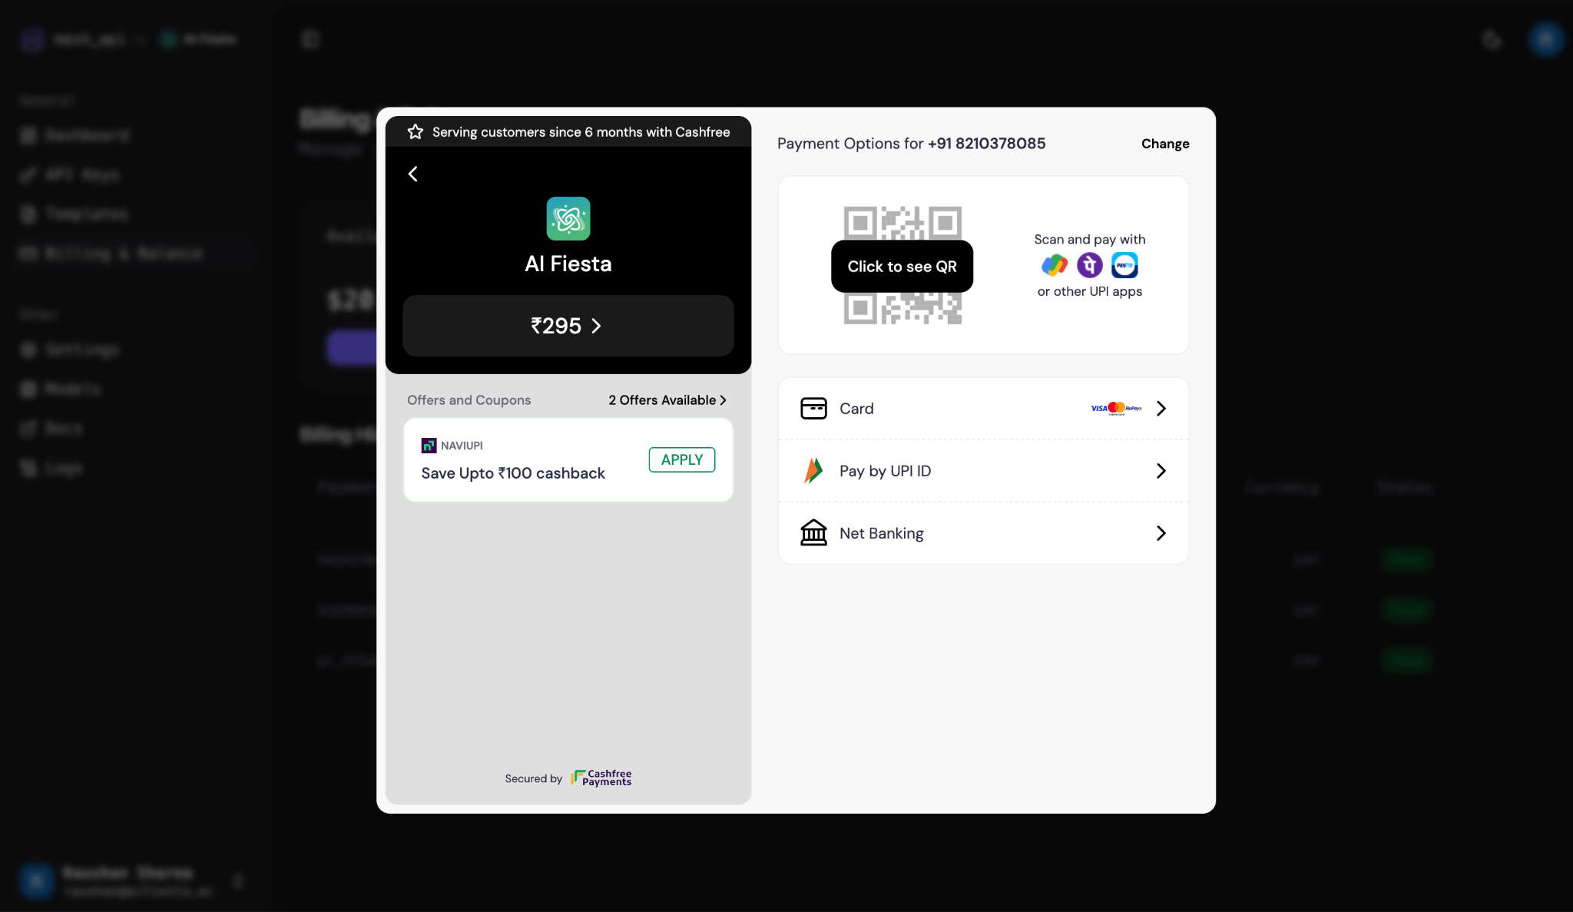

In the Apply Coupon field, enter KRISH01250 and click Apply.
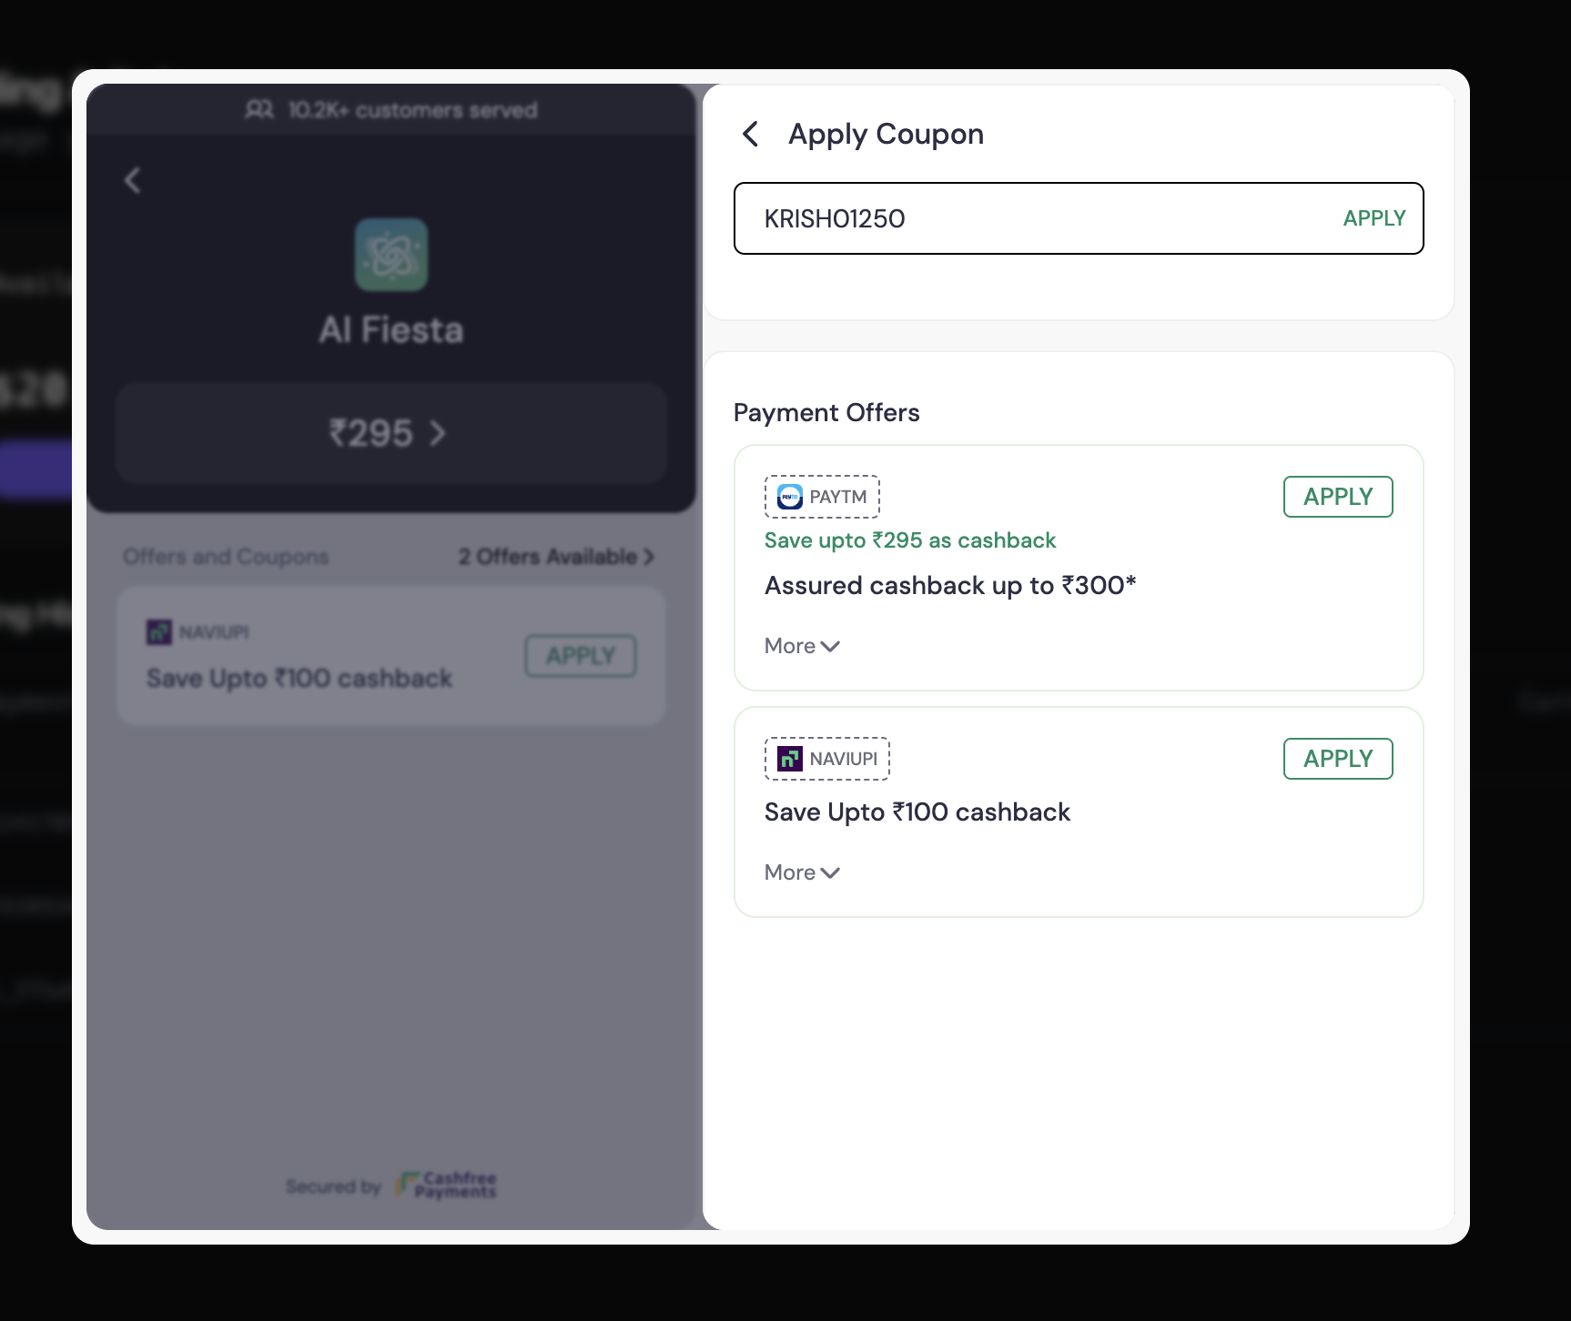

The payable amount will drop to ₹2 after the coupon is applied - complete the payment to activate your credits.
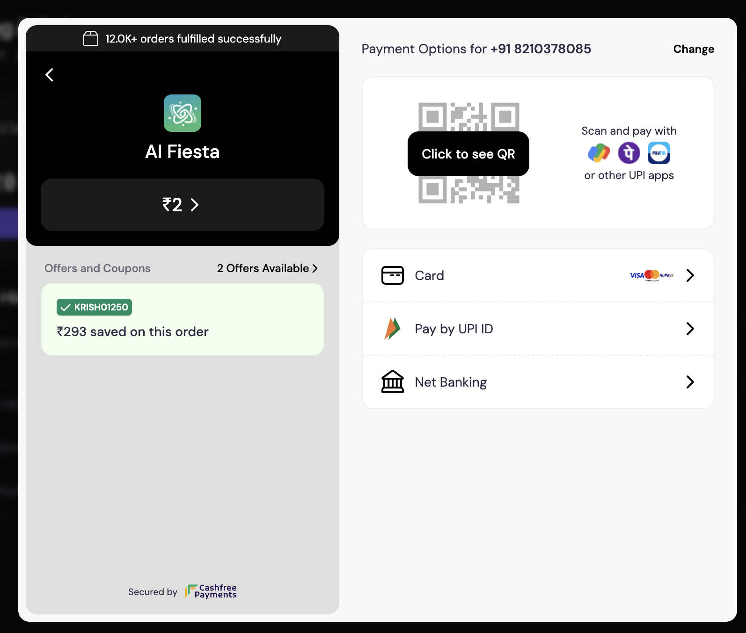

Once the payment is confirmed, you'll be redirected back to Mesh API with your balance topped up and ready to use.

—---- End of Document —----

